Experiment-09
Question: 1
Write a program to read the text from a given file “Poems.txt” and find out whether it contains the words “Twinkle” and “Star”. First create a text file that contains the poem “twinkle twinkle little star”
Code:
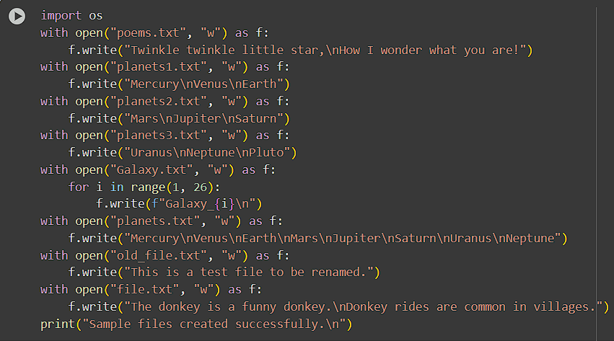
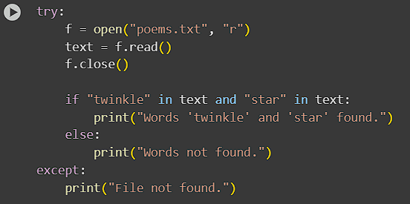
Output:
Question: 2
Write a python program to open three files planets1.txt, planets2.txt and planets3.txt. If any of these files are not present, a message without exiting the program must be printed promoting the same.
Code:
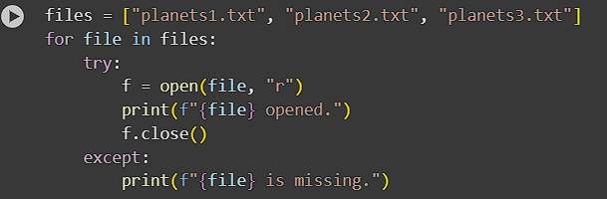

Output:
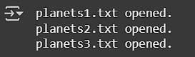
Question: 3
Write a program to make a copy of a text file “Galaxy.txt”.
Code:
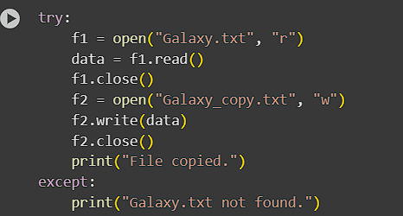
Output:

Question: 4
Write a program to wipe out the contents of a file using python.
Code:
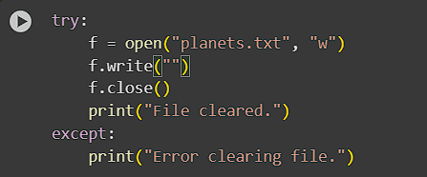
Output:

Question: 5
Write a python program to rename a file to “renamed_by_python.txt”.
Code:
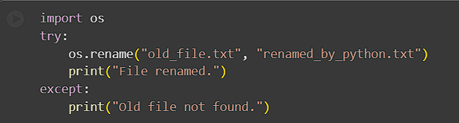

Output:

Question: 6
A file contains a word “donkey” multiple times. You need to write a program which replaces this word with $$$$$ by updating the same file.
Code:
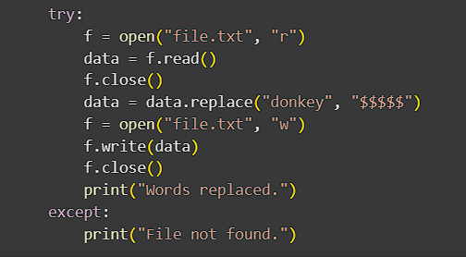
Output:


Submitted by:
Name= Abhinav Sharma
Reg no.= 2401020441
Branch= AI & DS
Group= 4

